**H.O.D CERTIFICATE**

This is to certify that,

Miss. Priya Shivling Koneri, Miss. Supriya Krishnat Kumbhar, Miss. Pradnya Arun Mali and Miss. Mrunali Maruti Patil have satisfactorily completed the project work entitled "**Online web portal for Green Metrics Calculations and Analysis** " for Vivekanand College, Kolhapur (Empowered Autonomous) as a partial fulfilment of the course B.Sc. in Computer Science of Shivaji University, Kolhapur for academic year 2023-24. To the best of my knowledge and belief, the project presented by them is original work and is not copied from any source.

**Date:** 13/03/2024

**Place:** Kolhapur

Dr. V. B. Waghmare

(H.O.D of Computer Science Department)

﻿

**ACKNOWLEGEMENT**

We would like to express our gratitude and appreciation to Dr. V. B. Waghmare Sir and Dr. I. K. Mujawar Sir who gave us the valuable guidance and useful suggestions to complete the project .

Special thanks to our supervisor Dr. R. Y. Patil Mam whose help, stimulating suggestions and encouragement helped us in preparing this project. We also sincerely thanks for the time spent proof reading and correcting our mistakes and also to for valuable guidance and useful suggestions.

In the last but not least we thanks to the members of Computer Science Department who have directly or indirectly helped us in completion of this project.

Miss. Priya Shivling Koneri Miss. Pradnya Arun Mali

Miss. Supriya Krishnat Kumbhar Miss. Mrunali Maruti Patil

**DECLARATION**

Το

The Principal,

Vivekanand College (Empowered Autonomous),

Kolhapur

We undersigned declare that the project report on "**Online web portal for Green Metrics Calculations and Analysis**" is developed by us.

This project work is completed under the guidance of Dr. R. Y. Patil. The findings in this project are based on data collected by us. We understand that any such copying is liable to be punished in a way the college authorities deem it.

**Date:** 13/03/2024

**Place:** Kolhapur

Miss. Priya Shivling Koneri Miss. Pradnya Arun Mali

Miss. Supriya Krishnat Kumbhar Miss. Mrunali Maruti Patil

**GUIDE CERTIFICATE**

This is to certify that,

Miss. Priya Shivling Koneri, Miss. Supriya Krishnat Kumbhar, Miss. Pradnya Arun Mali and Miss. Mrunali Maruti Patil have statisfactory carried out the project work entitled on “**Online web portal for Green Metrics Calculations and Analysis**” for Vivekananad College, Kolhapur (Empowered Autonomous) as partial fulfilment of course BSc. In Computer Science of Shivaji University, Kolhapur for academic year 2023-2024. To best of my knowledge and belief the project presented by them is the original work and not copied from any source.

Date : 13/03/2024

Place : Kolhapur

Dr. R. Y. Patil

(Project Guide)

**INDEX**

|  |  |
| --- | --- |
| **TITLE** | **PAGE NO** |
| **1.INTRODUCTION**  1.1 Introduction  1.2 System Analysis  1.2.1 Purpose of the project  1.2.2 Existing System |  |
| **2.PROPOSED SYSTEM**  2.1Proposed System  2.2 Objectives  2.3 Development Methodology |  |
| **3.SYSTEM DIAGRAMS**  3.1 Data Flow Diagram(0 level)  3.2 Entity Relationship Diagram (ERD)  3.3 Use Case Diagram  3.4 Project Flowchart Diagram |  |
| **4. SYSTEM DESIGN**  4.1 Database Design  4.2 Input Screen  4.3 Output Screen  4.4 Reports |  |
| **5. LIMITATIONS** |  |
| **6. FUTURE WORK** |  |
| **7. CONCLUSION** |  |
| **8. BIBLIOGRAPHY** |  |

**INTRODUCTION**

**1.1 Introduction:**

The **"Green Metrics Calculations and Analysis"** is a visionary software project designed to calculate green metrics easily. By harnessing the power of technology, this project aims to provide users with a robust and user-friendly solution for measuring, analysing, and reducing their environmental footprint.

The chemistry department is conducting research on “GREEN METRICS Calculations Analyser” and the difficult part of their research is to do 15-20 calculations for each product so, with this project we are going to create a software which will make these calculations easier and faster. Green chemistry metrics describe aspects of a chemical process relating to the principles of Green Chemistry.

The Green Metrics Analyser is a powerful tool designed to streamline the process of calculating and tracking various sustainability and environmental metrics. It's a software or web-based application that automates and simplifies complex calculations, making it easier for businesses, organizations, and individuals to assess their environmental impact and make informed decisions to reduce it.

One of the key advantages of the Green Metrics Analyser is its ability to save valuable time. Traditionally, calculating green metrics, such as carbon emissions, water usage, energy consumption, and waste generation, can be a time-consuming and labor-intensive process.

The Green Metrics Calculator automates these tasks, significantly reducing the time and effort required for these calculations.

**1.2 System Analysis:**

* + 1. **Purpose of the Project**

The primary purpose of the Green Metrics Analyzer is to empower users to assess their environmental impact accurately and efficiently. By automating complex calculations related to green chemistry metrics, the software enables users to make informed decisions to minimize their carbon footprint, water usage, energy consumption, and waste generation. Whether used by research institutions, manufacturing companies, or individuals, the Green Metrics Analyser serves as a valuable tool for promoting environmental sustainability and responsible resource management.

**Key Features:**

**1. Automated Calculations:** The Green Metrics Analyzer automates the process of calculating various green chemistry metrics, eliminating the need for manual calculations and reducing the risk of errors.

**2. Comprehensive Analysis:** Users can conduct in-depth analyses of their environmental impact by measuring factors such as carbon emissions, water usage, energy consumption, and waste generation.

**3. Customizable Parameters:** The software allows users to customize input parameters based on their specific requirements and industry standards, ensuring accurate and relevant results.

**4. Data Visualization:** The Green Metrics Analyzer provides intuitive data visualization tools, allowing users to interpret and communicate their results effectively through charts, graphs, and reports.

**5. Scalability:** Whether used for individual projects or large-scale operations, the Green Metrics Analyser is designed to accommodate varying levels of complexity and volume of calculations.

**Benefits:**

**1. Time Savings**: By automating complex calculations, the Green Metrics Analyser saves users valuable time and resources, allowing them to focus on strategic decision-making and sustainability initiatives.

**2. Accuracy:** The software ensures accuracy and consistency in environmental impact assessments, minimizing the risk of errors associated with manual calculations.

**3. Cost Efficiency:** By optimizing resource utilization and identifying areas for improvement, the Green Metrics Analyser helps organizations reduce operational costs and enhance overall efficiency.

**4. Environmental Guardianship**: By promoting awareness and accountability for environmental impact, the software encourages proactive measures to mitigate negative effects on the environment and promote sustainability.

**1.2.2Existing Systems:**

**This are the active existing systems:-**

|  |  |
| --- | --- |
| **Tool** | **Description** |
| **PMI Predictor** | Calculates process mass intensity (PMI) for a chemical synthesis route using the sequence of synthetic steps and step information. |
| **iGAL2.0 Scorecard Calculator** | Produces the scorecard output for an active pharmaceutical ingredient (API) using the model of innovative green aspiration level - iGAL 2.0 |
| **AMGS Calculator** | Calculates an analytical method greenness score (AMGS) to enable the comparison of separation methods used in drug development. |
| **Chemotion** | Open Source electronic lab notebook for researchers with a green chemistry tab. |
| **CHEM21 toolkit** | Evaluating sustainability of reactions, covering quantitative and qualitative criteria both upstream and downstream of the reaction itself. |

**Drawbacks of the above exiting systems are as follows:**

1. **Data Entry Burden**: Inputting all the required data and information into these systems can be time-consuming and labor-intensive, potentially slowing down research or project workflows.
2. **Limited Scope:** Some of these tools may have limitations in terms of the types of reactions, processes, or industries they can effectively evaluate, which might not cover all research needs.
3. **Cost:** Acquiring and implementing these systems may involve significant upfront costs, including software licenses, hardware, and training expenses. This cost factor can be a barrier for smaller research groups or organizations.

**To overcome the above drawbacks, we are developing a computerized “Green Metrics Analyser”**

**PROPOSED SYSTEM**

**2.1 Proposed System:**

* In the proposed system we are developing **“Online Green Metrics Calculations and Analysis”** web portal for green metrics calculations and analysis.
* The aim of the proposed system is to develop a system for Green metrics calculations(EMY,AE,AEF,CE,RME,OE,PMI,MI,MP,E-Factor,SI,WI,TON,TOF) and to measure the efficiency and environmental performance of chemical processes
* The proposed system can overcome the limitations of existing system.
* Users will have the ability to generate customizable reports based on their specific needs and requirements, providing valuable insights into green metrics and process efficiency.
* The proposed system automates chemical calculations, analyses multicomponent reactions, minimizes errors in green metrics calculations, and provides graphical representation for data analysis.
* The system will feature an intuitive and user-friendly interface to ensure ease of use for both experts and non-experts in chemical engineering and environmental science.

**Development Environment:**

|  |  |
| --- | --- |
| ***Scripting Language*** | ***Python*** |
| Designing and Scripting Language | HTML, CSS, Java Script |
| DBMS Environment | MySQL |
| Open-Source Libraries | MySQL Connector, fpdf |

**2.2 Objectives**

* To measure the efficiency and environmental performance of chemical processes.
* To find the efficiency and yields of the multicomponent reactions.
* To minimize errors while performing green metrics calculations manually.
* To compare the various chemical processes and to choose best among them for further experimentation.
* To represent chemical process data graphically for better analysis.
* To design the software that helps to find chemical process for commercial purpose to identify areas where they can reduce waste and improve efficiency, ultimately leading to cost savings.

**Features:**

* **1. Efficiency Measurement:** The system will allow users to measure the efficiency and environmental performance of chemical processes accurately. Through automated calculations and analysis, users can quantify the environmental impact of their processes in terms of factors such as carbon emissions, water usage, energy consumption, and waste generation.
* **2. Multicomponent Reaction Analysis**: Users will be able to analyse the efficiency and yields of multicomponent reactions efficiently. The system will provide tools for conducting detailed assessments of reaction outcomes, identifying key parameters influencing yield and efficiency, and optimizing reaction conditions accordingly.
* **Automates Calculations:** By automating green metrics calculations, the system will help minimize errors associated with manual calculations. Users can rely on the accuracy and consistency of automated calculations, reducing the risk of errors in environmental impact assessments.
* **4. Process Comparison:** The system will facilitate the comparison of various chemical processes, enabling users to identify the best options for further experimentation. Through side-by-side analysis of process parameters and environmental metrics, users can make informed decisions to optimize their processes for efficiency and sustainability.
* **Graphical Representation:** Users will have the ability to represent chemical process data graphically for better analysis and visualization. The system will offer a range of visualization tools, including charts, graphs, and dashboards, allowing users to interpret and communicate their results effectively.
* **6. Commercial Process Identification:** The system will include features to help users identify chemical processes for commercial purposes, with a focus on reducing waste and improving efficiency. By analysing process data and identifying areas for optimization, users can achieve cost savings and enhance overall productivity.
* **7. Cost Savings:** Through the optimization of chemical processes and the identification of areas for improvement, the system will contribute to cost savings for businesses and organizations. By reducing waste, minimizing resource consumption, and improving efficiency, users can achieve tangible cost benefits and enhance their competitive edge in the market.
* **8. User-Friendly Interface**: The system will feature a user-friendly interface designed for ease of use and accessibility. Intuitive navigation, clear instructions, and interactive tools will ensure that users can efficiently leverage the system's capabilities without extensive training or technical expertise.
* **9. Customization Options:** The system will offer customization options to accommodate users' specific requirements and preferences. Users can adjust settings, input parameters, and analysis criteria to tailor the system to their unique needs and objectives.
* **10. Data Security:** The system will prioritize data security and privacy, implementing robust measures to safeguard sensitive information. Data encryption, access controls, and regular backups will ensure the integrity and confidentiality of Features of the Proposed System

.

Overall, the proposed system will serve as a comprehensive and versatile tool for measuring, analysing, and optimizing chemical processes for efficiency, sustainability, and cost savings. By empowering users with advanced features and capabilities, the system will drive innovation and progress in the field of green chemistry and environmental guardianship data.

**2.3 Development Methodology:**

Development Methodology: **Waterfall Model for Green Metrics Project**

The Waterfall Model is a sequential and linear approach to software development that divides the project lifecycle into distinct phases. Each phase must be completed before the next phase begins, making it suitable for projects with well-defined requirements and objectives, such as the **Online Green Metrics Calculations and Analysis** project. Below is a breakdown of how the Waterfall Model can be applied to the development of the Green Metrics Analyser:

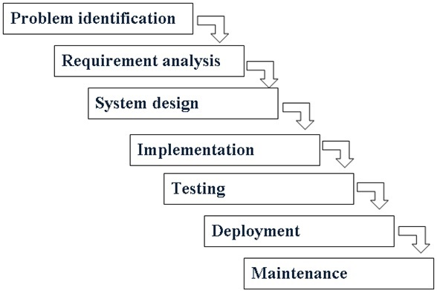

**1. Requirements Gathering:**

- In this initial phase, the development team will gather detailed requirements from stakeholders, particularly the chemistry department and potential end-users.

- Requirements will include specific functionalities, calculations, data visualization requirements, and user interface preferences.

- A comprehensive requirements document will be prepared based on these inputs, serving as the foundation for the entire project.

**2. System Design:**

- Once requirements are gathered and documented, the system architecture and design will be planned.

- This phase involves defining the overall structure of the software, including the database schema, user interface layout, and system components.

- Detailed design documents, including flowcharts, diagrams, and mockups, will be created to visualize the system's structure and functionality.

**3. Implementation:**

- With the design in place, the development team will proceed to implement the software according to the specifications outlined in the requirements and design documents.

- This phase involves writing code, configuring databases, and integrating various components to build the Online Green Metrics Calculations and Analyser.

- Each module or feature will be developed sequentially, with regular code reviews and testing to ensure quality and adherence to requirements.

**4. Testing:**

- Once the implementation is complete, the testing phase begins.

- Testing will include unit testing to validate individual modules, integration testing to verify interactions between components, and system testing to evaluate the software as a whole.

- Test cases will be designed based on the requirements and executed systematically to identify defects and ensure the software functions as intended.

**5. Deployment:**

- Upon successful completion of testing, the Online Green Metrics Calculations and Analyser will be deployed to the production environment.

- This phase involves preparing the software for release, configuring servers and databases, and ensuring all dependencies are met.

- User training and documentation will be provided to facilitate the adoption of the software by stakeholders.

**6. Maintenance:**

- After deployment, the development team will continue to provide maintenance and support for the Online Green Metrics Calculations and Analyser.

- This includes addressing any issues or bugs discovered post-deployment, implementing updates or enhancements based on user feedback, and ensuring the long-term reliability and performance of the software.

By following the Waterfall Model, the development team can systematically progress through each phase of the project, ensuring that requirements are met, and the Online Green Metrics Calculations and Analyser is delivered successfully with minimal rework. While the Waterfall Model may not be as flexible as other development methodologies, its structured approach is well-suited for projects with clear objectives and predictable requirements, such as the development of the Online Green Metrics Calculations and Analyser.

.

**SYSTEM DIAGRAM**

**3.1Data Flow Diagram (0 level):**

login

Green Metrics calculation page

Fill inputs and submit

User

Provide all calculated output in table format

Wants Graphical Analysis

Give graphical

**3.2Entity Relationship Diagram:**

report

1

1

userlog

**3.4 Use case Diagram:**

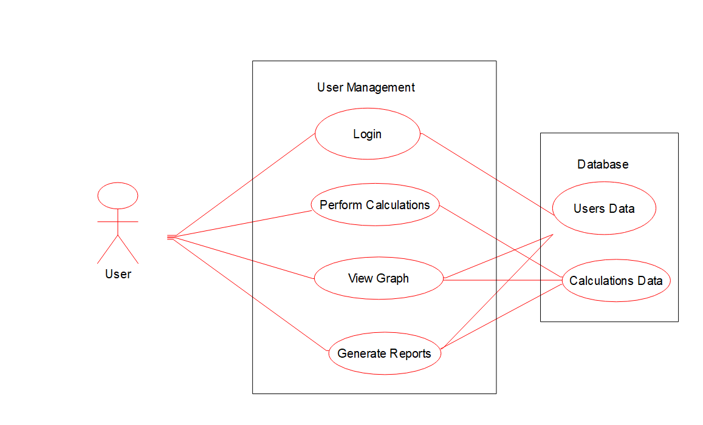

**SYSTEM DESIGN**

**4.1 Database Design:**

**Tables:**

* **Userlog :** For storing information of users
* **Report:** For storing all green metrics calculations for specific product name and generating reports according to username.

**1. Table Name: userlog**

|  |  |  |  |
| --- | --- | --- | --- |
| **Field Name** | **Data Type** | **Description** | **Constraint** |
| id | int | User Id | Primary key  auto-increment  Not null |
| username | varchar(50) | User name | Not null |
| password | varchar(50) | User password | Not null |
| email | varchar(50) | User email | Not null |

**2. Table Name: report**

|  |  |  |  |
| --- | --- | --- | --- |
| **Field Name** | **Data Type** | **Description** | **Constraint** |
| product-name | varchar(40) | Product name | Primary key  Not null |
| yeild | float | Product yield | Primary key  Not null |
| time | float | Product time | Primary key  Not null |
| emy | float | Effective Mass Yield | Not null |
| ae | float | Atom Economy | Not null |
| aef | float | Atom Efficiency | Not null |
| ce | float | Carbon Efficiency | Not null |
| rme | float | Reaction Mass Efficiency | Not null |
| oe | float | Optimum Efficiency | Not null |
| pmi | float | Product Mass Intensity | Not null |
| mi | float | Mass Intensity | Not null |
| mp | float | Mass Productivity | Not null |
| e-factor | varchar(40) | E-Factor | Not null |
| si | float | Solvent Intensity | Not null |
| wi | float | Water Intensity | Not null |
| ton | float | Turn Over Number | Not null |
| tof | float | TurnOver Frequency | Not null |
| user | varchar(40) |  | Primary key  Not null |

**INPUT SCREEN**

**OUTPUT SCREEN**

**REPORTS**

**GRAPH**

**Limitations of project on Online Portal for Green Metrics Calculations and Analyser:**

**1. Data Quality and Availability:** Emphasize the dependence of the software's accuracy on the quality and availability of input data. Discuss potential challenges in obtaining reliable data, such as inconsistencies in data sources or gaps in data coverage, which may limit the software's effectiveness in providing accurate environmental assessments.

**2. Scope and Coverage:** Highlight any limitations in the scope and coverage of the software in terms of the environmental metrics it can analyse and the industries or sectors it can serve effectively. Discuss any specific metrics or sectors that may not be adequately addressed by the current version of the software, limiting its applicability to certain users or contexts.

**3. Resource Requirements**: Evaluate the resource requirements associated with deploying and maintaining the software, including computing power, storage, and ongoing support and maintenance. Discuss potential challenges for organizations with limited resources or infrastructure, which may limit their ability to fully leverage the software's capabilities**.**

**Conclusion**

The **Online Green Metrics Calculations and Analyser** project promises to revolutionize environmental impact assessment by providing a user-friendly platform for calculating and tracking sustainability metrics. Its automated calculations and customizable parameters offer significant time savings and accuracy improvements, empowering users to make informed decisions towards environmental stewardship. With its comprehensive features and benefits, the ‘Online Green Metrics Calculations and Analyser’ has the potential to become an indispensable tool for businesses and organizations striving for sustainable practices.

1. The Online Green Metrics Calculations and Analyser’ project addresses the growing need for efficient and accurate environmental impact assessment in today's business landscape.

2. Its automated calculations streamline the process of measuring and tracking sustainability metrics, saving valuable time and resources for users.

3. Customizable parameters allow users to tailor their analyses to specific requirements and industry standards, ensuring relevance and accuracy.

4. The software's intuitive data visualization tools enable users to interpret and communicate their results effectively, facilitating informed decision-making.

5. With its focus on environmental stewardship and responsible resource management, the Online Green Metrics Calculations and Analyser’ aligns with global efforts towards sustainability and green chemistry principles.

**Bibliography:**

[**https://www.w3schools.com/**](https://www.w3schools.com/)

[**https://www.geeksforgeeks.org/**](https://www.geeksforgeeks.org/)

[**https://www.tutorialspoint.com**](https://www.tutorialspoint.com)

[**https://www.youtube.com/**](https://www.youtube.com/)

[**https://en.wikipedia.org/wiki/Green_chemistry_metrics**](https://en.wikipedia.org/wiki/Green_chemistry_metrics)

**Research paper (by Archana Rajmane Maam**

[**https://scholar.google.com/citations?view_op=view_citation&hl=en&user=403UyOAAAAAJ&citation_for_view=403UyOAAAAAJ:zYLM7Y9cAGgC**](https://scholar.google.com/citations?view_op=view_citation&hl=en&user=403UyOAAAAAJ&citation_for_view=403UyOAAAAAJ:zYLM7Y9cAGgC)

**(**  
[DABCO-C18] Br: A novel basic surfactant for the synthesis of dihydropyrano [3, 2-c] chromenes and 2-aminobenzochromenes under ambient conditions**)**

**Thank-You**